Cell Respiration Lab

Purpose: The purpose of this investigation is to investigate the effect of temperature on the rate of respiration.

Materials:
.Peas germinated 24 hours and peas germinated 48 hours
.15% KOH
.absorbent cotton
.glass beads
.nonabsorbent cotton
.100 ml graduated cylinder
.3 respirometers

Procedure:
1. Assemble three respirometers.

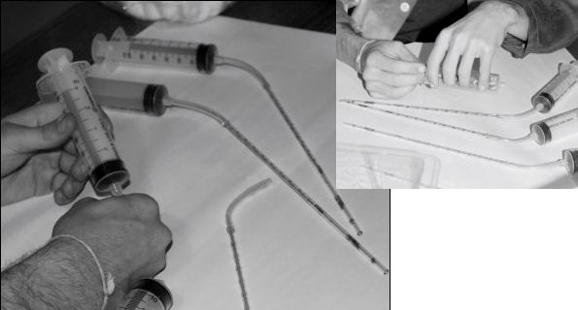

- Respirometer 1: Mass 25 peas that have been germinating for 24 hours. Put those 25 in the first respirometer. Take an absorbent cotton ball and using a dropper, place 5-6 drops of KOH on the cotton. Using forceps sandwich this cotton ball between two layers of nonabsorbent cotton and place that on top of the germinating peas. Pull the plunger to the 5 cc mark.
- Respirometer 2: Mass 25 peas that have been germinating for 48 hours. Put those 25 in the second respirometer. Take an absorbent cotton ball and using a dropper, place 5-6 drops of KOH on the cotton. Using forceps sandwich this cotton ball between two layers of nonabsorbent cotton and place that on top of the germinating peas. Pull the plunger to the 5 cc mark.
- Respirometer 3: Put 25 glass beads in the third respirometer. Take an absorbent cotton ball and using a dropper, place 5-6 drops of KOH on the cotton. Using forceps sandwich this cotton ball between two layers of nonabsorbent cotton and place that on top of the glass beads.
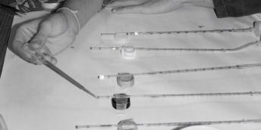
- Allow the respirometer to set and equilibrate for 3 minutes.
- Place the end pipette on bottle cap and tape this down.
- Add a drop of dye to the open end of the pipette.

- Push the plunger to adjust the dye so that the front of the dye is at the 0 mark of the pipette.
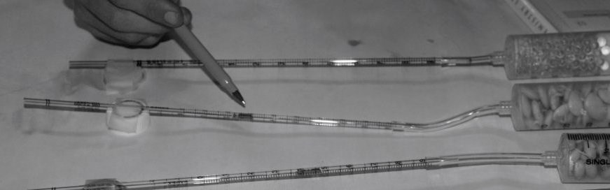
- Start recording the movement of the dye every minute for 15 minutes.
- Graph your data.
- Determine the average rate of respiration for germinating peas for both peas germinating for 24 hours and 48 hours.
- Collect the class data for the total amount of oxygen consumed for 15 minutes. Analyze this data to determine if the amount of time allowed for germination has an impact on cellular respiration.
Part B Propose another question to investigate concerning cellular respiration.
Time | Change in O₂ volume beads | O₂ consumed by peas 24 hours germination | Change in O₂ volume beads adjusted for  environmental factors | O₂ consumed by peas 48 hours germination | Change in O₂ volume beads adjusted for  environmental factors
0
1.0
2.0
3.0
4.0
5.0
6.0
7.0
8.0
9.0
10.0
11.0
12.0
13.0
14.0
15.0
Design an experiment to investigate your question.

1. What is the general purpose of cellular respiration?
Questions

. 2. What are the two parts of respiration?

.3. What is the most common form of chemical energy used by our cells?

.4. Why is ATP used for cellular energy instead of glucose?

5. What role does glucose play in cellular respiration?

.6. Did the length of germination have a significant impact on the amount of oxygen consumed? Justify your answer

.7. Adjust your data for mass and statistically analyze to see if the length of germination has a significant impact on the amount of oxygen consumed.

